05-Simple Storage Service (S3)
Friday, February 14, 2025
12:19 PM

🗄️ What Is S3?
  - 🪣 S3 → Object Storage (Service) solution given by AWS
  - ⚙️ Serverless Storage Solution → The service in which you are not supposed to manage.
(There must be a server, running in the data center for storage purpose.)

📐 Key Characteristics
🔑 Feature | 📋 Detail
📏 Infinitely Scaling Storage | It has Elasticity — There is no size of the bucket
🌐 Backbone for Websites | Because of Durability — Ability to last over time (99.9999999%)
🖼️ Recommended for Static Content | Graphic files, audio, video, compressed files etc…

📦 Storage Limits
📊 Metric | 🔢 Limit
🪣 Total Bucket Size | Unlimited
📁 No. of Objects per Bucket | Unlimited
📄 Maximum Size per Object | 5 TB
⬆️ Maximum Size for a Single Upload | 5 GB

🌍 Bucket Rules

  - 🔀 PUT Operation → Adding an object to a specified bucket
  - 🌐 Globally Unique Name → Buckets must have globally unique name (across all regions and all accounts)
Account Regional Namespaces AWS introduced account regional namespaces for S3 general-purpose buckets.
  - Instead of competing in the global pool, bucket names can be scoped strictly to your AWS Account ID and Region.
  - AWS automatically appends an account-regional suffix (e.g., mybucket-123456789012-us-east-1-an), eliminating naming collisions while maintaining unique routing.

  - 📍 Region Level → Buckets are defined at the region level

📝 Naming Convention Rules

✅ Rule 1 → No uppercase, No underscore
Must start with lowercase or number

✅ Rule 2 → 3–63 characters long
Must NOT start with the prefix e.g., xn_

✅ Rule 3 → Not an IP
Must NOT end with the suffix e.g., _s3alias

🗝️ Objects & Keys

  - 🔑 Objects have a key → Key is the full path of the object
  - 📂 Everything in S3 bucket → has a key
  - 🔀 Keys with long name → contain " / "

⚡ Performance & Best Practices

  - 📶 Throughput → Refers to the rate at which data is successfully transferred through a network or processed by a system
  - ✅ Opt for S3 → over other storage solutions
  - 🌐 Globally Unique → The bucket name should be globally unique, it should not get overlapped

🔒 Security

🔐 Object State | 👁️ Who Can Access
🔴 Private | As an owner of this bucket, you only able to access
🟢 Public | Anyone can access

  - 🔀 Object & Bucket visibility → We can make Object as Private or Public in the same way Bucket as Private or Public
  - ⚙️ Access Policy → Customize to access

🚀 Directory Buckets

ℹ️ Recommended for low-latency use cases. These buckets use only the S3 Express One Zone storage class, which provides faster processing of data within a single Availability Zone.

⚙️ Property | 📋 Detail
🎯 Use Case | Low-latency workloads
🗂️ Storage Class | S3 Express One Zone only
🏠 Availability | Single Availability Zone
⚡ Benefit | Faster processing of data

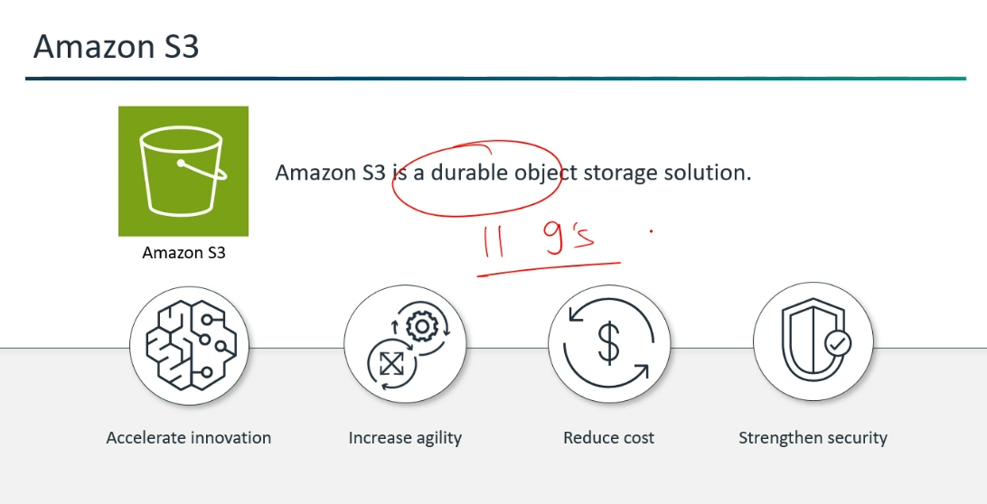

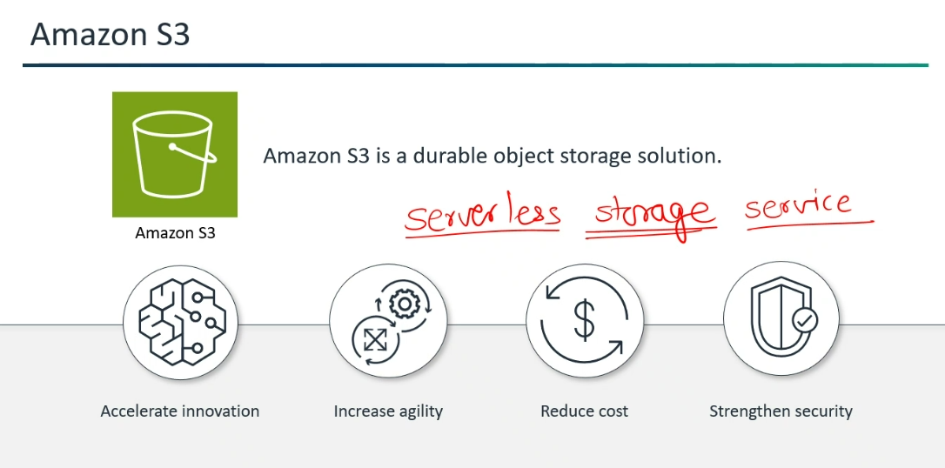

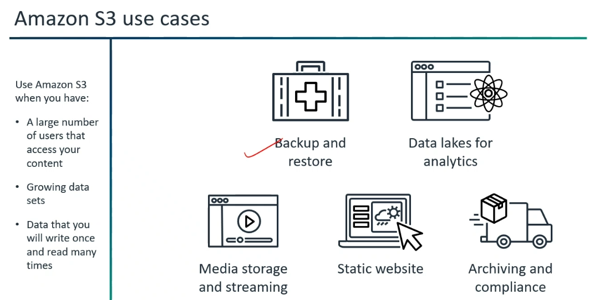

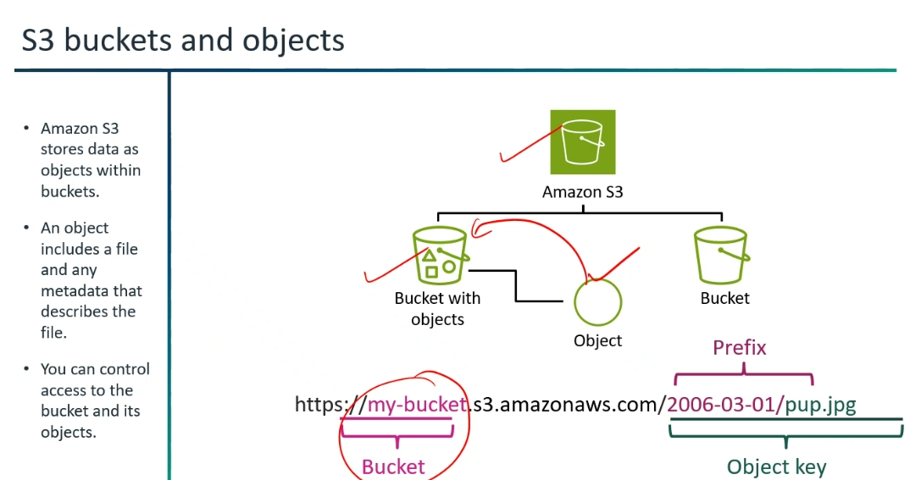



🏛️ S3 — Security Architecture Decision Guide 🏛️

Complete Study Notes | AWS SAA-C03 Exam Prep

ℹ️ Architects must know which mechanism to use based on the scenario.

1️⃣ Access Control Mechanisms

⚙️ Mechanism | 📋 What It Is | 🎯 When to Use
🪣 S3 Bucket Policies | Resource-based JSON policies applied directly to a bucket | Cross-account access, granting public access, or enforcing security rules (e.g., requiring HTTPS or blocking unencrypted uploads)
🧑 IAM User/Role Policies | Identity-based policies attached to users, groups, or roles | Controlling access from within the same AWS account
📜 Access Control Lists (ACLs) | Legacy access control mechanism | AWS best practice: Set Bucket Owner Enforced to disable ACLs entirely and rely solely on Bucket Policies and IAM policies
🔀 S3 Access Points | Named network endpoints attached to buckets | Simplify managing access at scale for distinct applications or datasets (e.g., separate endpoints for analytics vs. finance teams)
🌐 Cross-Account Access | Bucket Policy, IAM Roles (assuming roles), or AWS Resource Access Manager (RAM) | Depending on whether the requirement is static access or temporary session access

🔀 S3 Access Points: Dedicated network endpoints with custom policies that simplify permission management for specific applications or VPCs sharing a single bucket.

🔀 S3 Access Points
📋 Scenario: You have a shared S3 bucket (s3://company-data) used by both the Analytics team and the Finance team.
💡 Example: Instead of editing one huge, messy bucket policy, you create two distinct endpoints:
  - 💼 finance-access-point: Gives the Finance team access only to the /finance/ folder in the bucket.
  - 📊 analytics-access-point: Gives the Analytics team read-only access to the entire bucket, restricted exclusively to connections coming from inside your private VPC network.
⚙️ S3 Access Control Lists (ACLs): A legacy permission mechanism that grants basic access on individual objects or buckets, which AWS recommends keeping disabled in favor of IAM and Bucket Policies.
📋 Scenario: Granting access on a file-by-file basis rather than controlling the entire bucket.
💡 Example: You have a private S3 bucket containing 100 internal reports. You attach an ACL directly to a single file, public-summary.pdf, marking it as publicly readable so anyone with the URL can open it, while the rest of the 99 files remain completely private.

2️⃣ Public Access Control & Threat Mitigation

  - 🛡️ S3 Block Public Access → A centralized control at the account or bucket level that overrides all bucket policies and ACLs to prevent public exposure
  - 🔐
  - Delete → Requires Multi-Factor Authentication to permanently delete an object version or change bucket versioning states. Must be configured using the AWS CLI/API using the root account
  - 🔒 Object Lock → Implements Write-Once-Read-Many (WORM) storage to prevent object deletion or overwrite for a fixed retention period

🔒 Object Lock Modes
🔑 Mode | 📋 Behaviour
⚙️ Governance Mode | Privileged users (with specific IAM permissions) can bypass or alter retention settings
🔴 Compliance Mode | No user, including the AWS root account, can delete the object or alter retention settings until the retention period expires

3️⃣ Data Protection & Encryption

ℹ️ AWS tests when to use server-side vs. client-side encryption, key ownership, and performance/cost trade-offs.

🔐 Encryption at Rest
🔑 Type | 📋 Description | ⚙️ Key Management
🟢 SSE-S3 | Default encryption for S3 buckets using AES-256 | AWS fully manages keys
🔵 SSE-KMS | Uses keys managed in AWS KMS. Enables audit trails (CloudTrail logs key usage) and fine-grained key permissions | AWS KMS manages keys
🟡 SSE-C | The customer manages the encryption keys, while AWS manages the encryption process. AWS does not store the key | Customer manages keys
🔴 Client-Side Encryption | Data is encrypted locally on the client side before uploading to S3 | Customer manages everything

⚠️ Exam Gotcha: KMS API rate limits (GenerateDataKey/Decrypt) can cause throttling at high request volumes. Use S3 Bucket Keys to reduce KMS API calls and costs by up to 99%.
🔐 SSE-S3 (Amazon S3 Managed Keys)
  - ⚙️ How it works: S3 automatically handles all key creation, rotation, and 256-bit AES encryption behind the scenes.
  - 🎯 When to use: Standard file storage, static web assets, frontend build files, or general application storage.
  - 💡 Why: It is free, enabled by default, requires zero key management overhead, and meets standard data-at-rest encryption requirements.
🔑 SSE-KMS (AWS Key Management Service Keys)
  - ⚙️ How it works: Encrypts data using keys managed in AWS KMS. You can use the default AWS KMS key or create custom KMS keys.
  - 🎯 When to use: Sensitive business data, customer records, or workloads with strict compliance standards (e.g., PCI-DSS, HIPAA).
  - 💡 Why: Gives you granular access control over who can decrypt objects, along with detailed audit logs in AWS CloudTrail every time a key is used. (Note: Incurs additional KMS API costs).
🛡️ DSSE-KMS (Dual-Layer AWS KMS Keys)
  - ⚙️ How it works: Encrypts data twice at the object layer using two distinct AWS KMS keys.
  - 🎯 When to use: Strictly regulated defense, government, or high-security enterprise environments that mandate defense-in-depth compliance.
  - 💡 Why: Satisfies explicit legal or regulatory requirements for dual-layer encryption, though it doubles KMS request processing costs.
🧩 SSE-C (Customer-Provided Keys)
  - ⚙️ How it works: You send your own encryption key in the HTTPS header with every upload or download request. AWS encrypts the object and immediately discards your key from memory.
  - 🎯 When to use: On-premises hybrid setups where corporate compliance prohibits third parties (including AWS) from storing encryption keys.
  - 💡 Why: Gives complete key control, but if you lose the key, your data is permanently lost. Organizations frequently block this (as configured on your bucket screen) to prevent accidental data loss.

🌐 Encryption in Transit
  - 🔀 Enforced by → Adding a bucket policy condition that denies requests where aws:SecureTransport is false (forces HTTP traffic to be rejected in favor of HTTPS/TLS)

4️⃣ Network Isolation & Private Access

🔒 Mechanism | 📋 Description | 💰 Cost
🚪 Gateway VPC Endpoints  (S3 and DynamoDB) | Allows EC2 instances or services inside a private subnet to access S3 directly without traversing the public internet, a NAT Gateway, or Internet Gateway | ✅ Free
🔗 Interface VPC Endpoints  (AWS PrivateLink for S3) | Extends access to S3 from on-premises environments (via Direct Connect or Site-to-Site VPN) or peered VPCs using private IP addresses | 💲 Charged per hour/GB processed

  - 🔐 Restricting Access via Bucket Policy → Use aws:sourceVpce or aws:sourceVpc condition keys in S3 Bucket Policies to restrict bucket access exclusively to requests coming through specific VPC endpoints or VPCs

5️⃣ Auditing, Monitoring & Compliance

🔍 Service | 📋 What It Does
📋 AWS CloudTrail Integration | Logs all object-level API operations (GetObject, PutObject, DeleteObject) via CloudTrail Data Events for security audits
📝 S3 Server Access Logs | Captures detailed records for requests made to a bucket (useful for cost/usage tracking and security analysis)
🛡️ Amazon GuardDuty for S3 | Uses machine learning to detect unusual activity or potential threat patterns (e.g., unexpected data exfiltration, compromised credentials accessing buckets)
🔎 Amazon Macie | Uses machine learning and pattern matching to discover, classify, and protect Sensitive Personal Identifiable Information (PII) stored in S3

🎯 Typical Exam Scenario Decision Framework

📋 Scenario / Requirement | ✅ Recommended AWS Solution
🌐 Prevent accidental public leaks globally | Enable S3 Block Public Access at the Account level
🔴 Prevent regulatory data deletion (even by root) | Enable S3 Object Lock in Compliance Mode
🔒 Private EC2 access to S3 without internet | Create a Gateway VPC Endpoint for S3
🏢 Private On-Premises access to S3 | Use an Interface VPC Endpoint for S3
🔐 Enforce HTTPS-only uploads/downloads | Add a Bucket Policy denying aws:SecureTransport = false
🔎 Scan S3 buckets for sensitive PII/data exposure | Run Amazon Macie automated sensitive data discovery
⚡ Reduce KMS API throttling & costs for SSE-KMS | Enable S3 Bucket Keys

📦 S3 Versioning — Data Protection & History

🎯 Core Concept: Keeps multiple variants of an object in the same bucket to guard against accidental overwrites or deletions.

🪣 Bucket States

🔘 State | 📋 Description
⬜ Disabled | Default state — versioning is off, no version IDs assigned
✅ Enabled | Once enabled, it can NEVER be turned off completely — only Suspended
⏸️ Suspended | New objects stop receiving version IDs; existing versions are preserved

⚠️ Existing objects added prior to enabling versioning receive a null version ID.

🗑️ Deletion Mechanics

🔑 Delete Type | ⚙️ How It Works | 📋 Effect
🟡 Soft Delete  (Delete Marker) | Delete an object WITHOUT specifying a version ID | Creates a Delete Marker — object appears hidden in the console, but previous versions remain intact
🔴 Hard Delete | Specify an exact Version ID in the delete request | Permanently removes that specific version — cannot be undone
🔐 MFA Delete | Requires Multi-Factor Authentication — must be configured using the AWS CLI under the root account | Required to permanently delete object versions or alter bucket versioning settings
MFA Delete cannot be enabled through the AWS Management Console—it can only be configured using the AWS CLI or REST API while authenticated with AWS Account Root credentials.
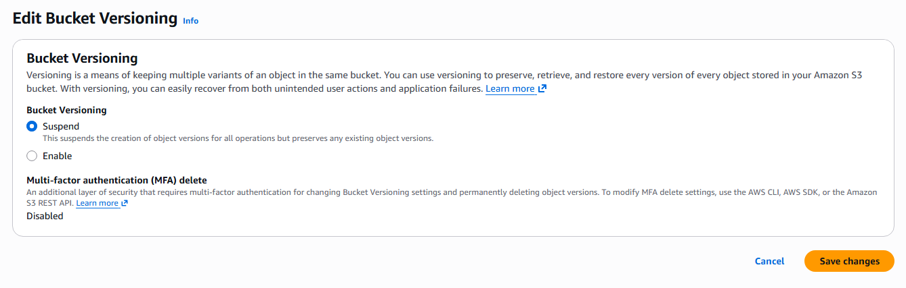
🔀 Replication Requirement

  - ✅ Versioning MUST be enabled → On BOTH source and destination buckets for Same-Region Replication (SRR) and Cross-Region Replication (CRR)

ℹ️ You cannot configure SRR or CRR unless versioning is active on both the source and destination bucket.

💰 Cost Factor

  - 📦 Every stored version → Counts as a full copy of the object and incurs standard storage costs
  - ⚙️ S3 Lifecycle Rules → Typically used to transition or expire non-current versions to reduce cost

💡 Exam Tip: Use S3 Lifecycle rules to automatically expire or transition old object versions — otherwise storage costs grow unbounded.

🔗 S3 Presigned URLs — Temporary Delegated Access

🎯 Core Concept: Grants temporary access to download (GET) or upload (PUT) a specific S3 object without modifying bucket policies or making the file public.

⚙️ How It Works

  - 🔑 Signing → An IAM user or role signs a URL using their AWS credentials, embedding permission and an expiration timestamp directly into the link
  - 👥 Anyone with the link → Inherits those specific access rights until it expires

🏗️ Architectural Pattern — Offloading Traffic

ℹ️ Instead of routing large web uploads through EC2 instances or AWS Lambda (which adds cost and latency), the backend server generates a Presigned URL and hands it to the client browser to upload directly to S3.

🔴 Without Presigned URL | ✅ With Presigned URL
Client → EC2 / Lambda → S3  (adds cost + latency) | Client → S3 directly via Presigned URL  (no EC2 / Lambda in the upload path)

⏱️ Expiration Limits

🔑 Credential Type | ⏱️ Expiration Behaviour
🧑 IAM User Credentials | Can be configured from as little as 1 second up to a maximum of 7 days
⚙️ Temporary Credentials  (e.g., EC2 IAM Role) | The URL expires when the role's temporary credentials expire

🛡️ Security Guardrail

  - 🔐 Permission Scope → The presigned URL only grants permissions that the creator actually possesses at the time of the request
  - ⚠️ If permissions are revoked → If the creating IAM identity loses permissions, the URL becomes invalid immediately

⚠️ A presigned URL cannot grant more permissions than the generating identity has. It is not a way to bypass IAM — it inherits from it.

🎯 Quick Reference Summary

📋 Feature | 📦 S3 Versioning | 🔗 Presigned URL
🎯 Purpose | Protect against accidental overwrites/deletions | Temporary delegated access to a specific object
🔘 Default State | Disabled | Generated on-demand — no default
🔁 Reversible? | ❌ Cannot disable once enabled — only Suspend | ✅ Expires automatically
🔐 MFA Required? | ✅ For permanent deletes (MFA Delete) | ❌ Not required
💰 Cost Impact | Every version = full storage cost | No extra cost — time-limited URL only
🔀 Replication | Required for SRR and CRR | Not applicable
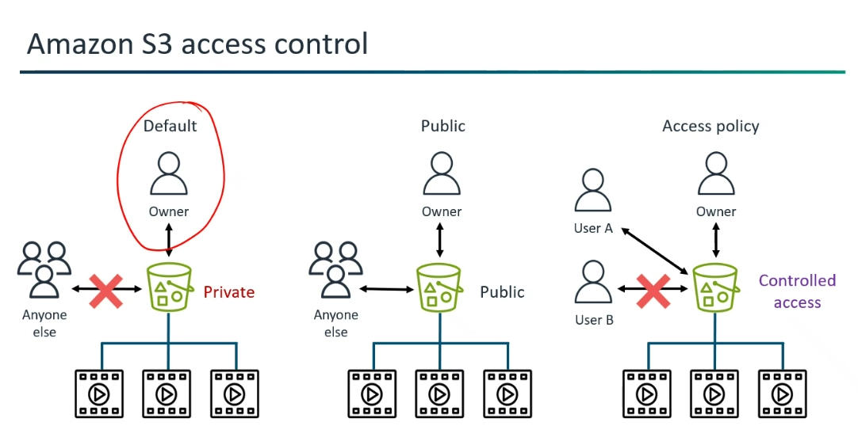

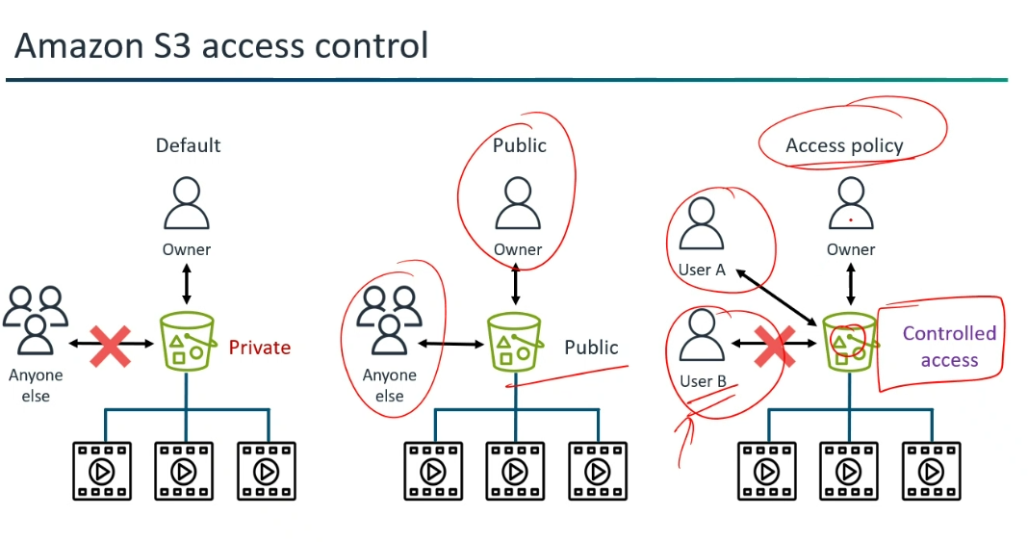

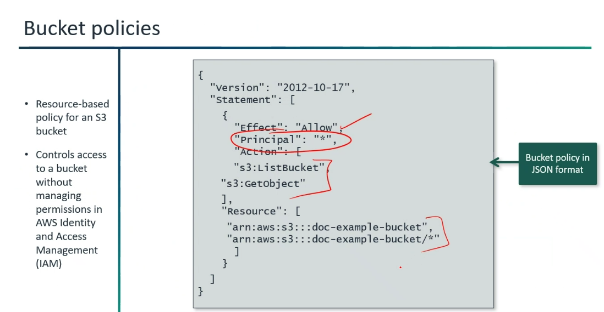

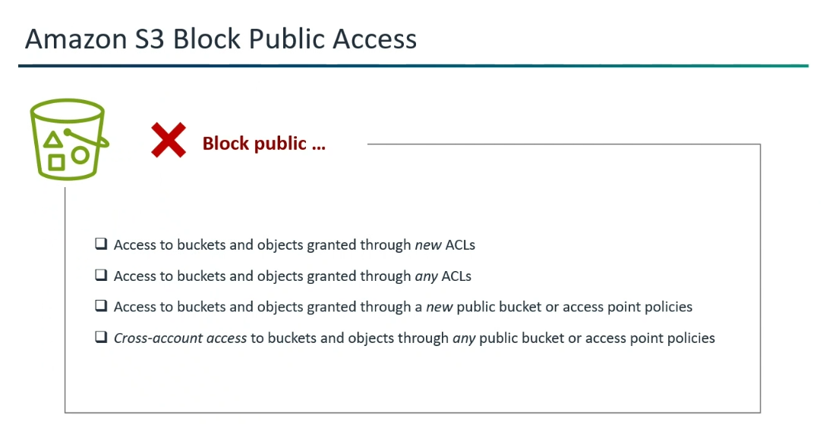
*If have given Object level permission, then can able to access the link in Google.
(If you enable it, you can access it)
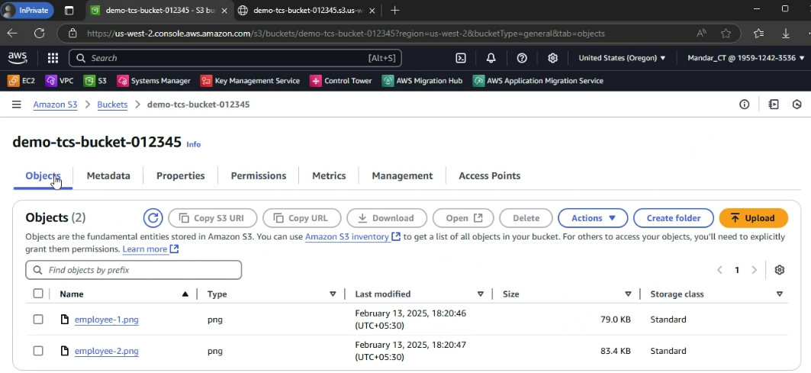

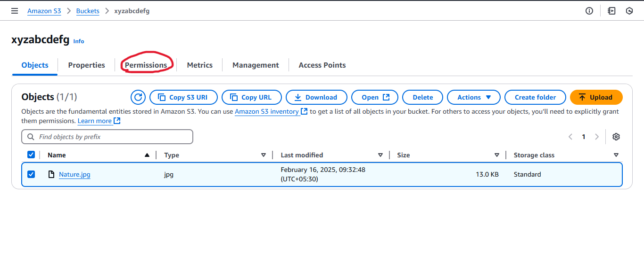

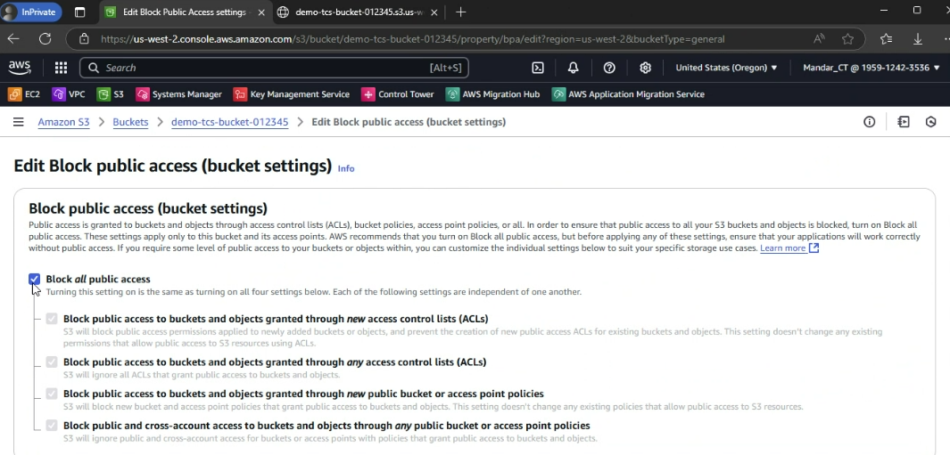

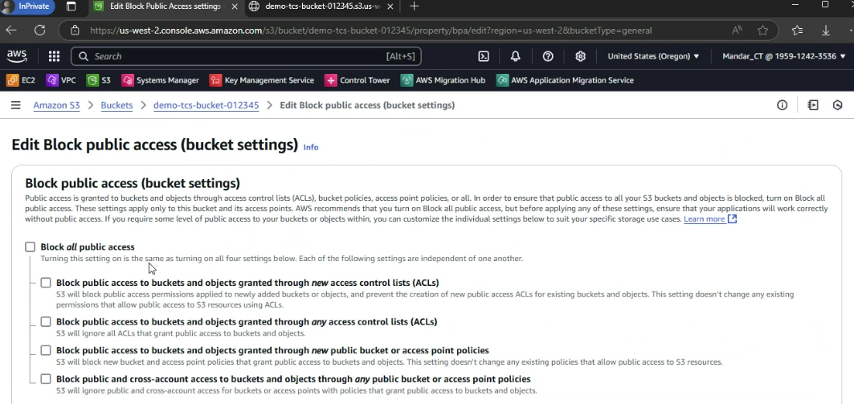

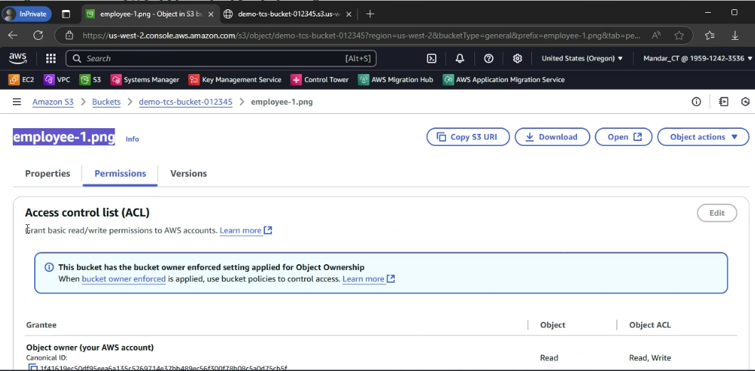
*Access Point is created.
*If IAM user wants to access objects by assuming the role, they can access the data only in the access point.
(Not access to all objects or buckets-->Google it)
*Two level of filtrations are there,
1)IAM Role
2)Access Point
Then, Bucket Objects.
*Pricing..?
Access Point is a Resource.
S3 Point is a Resource.

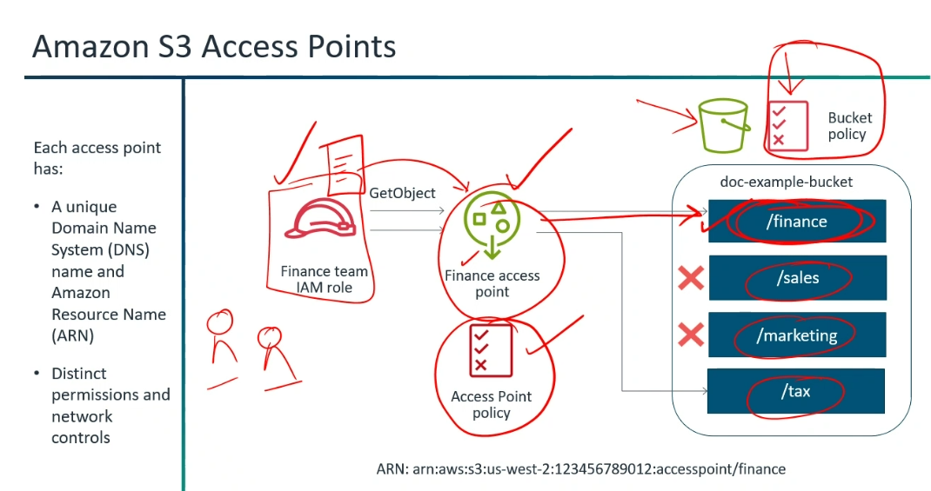

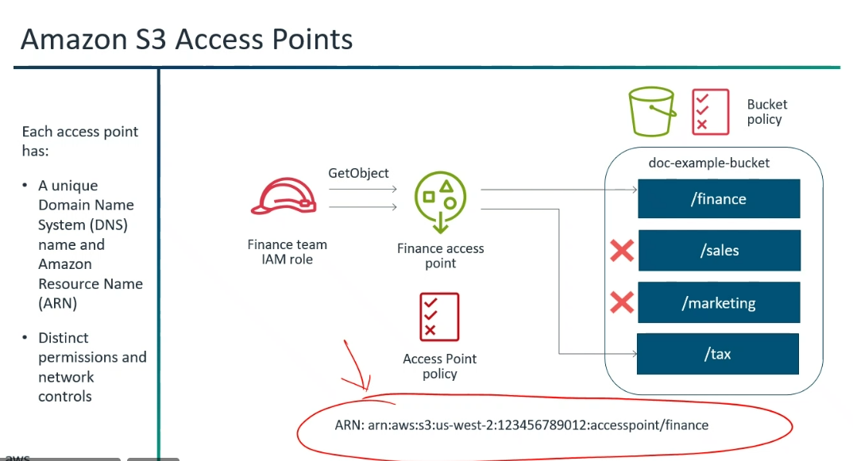

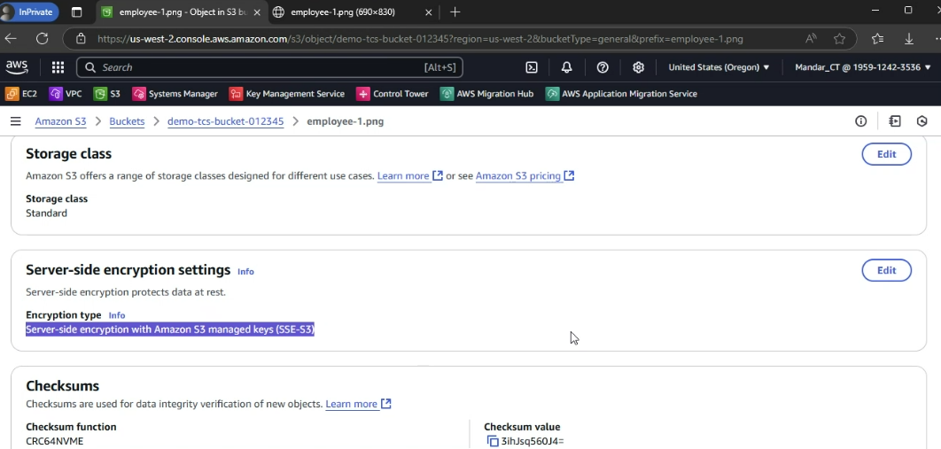
*If we do not rely on AWS key, we can go for KMS.
*Sever is providing encryption viz.,S3, KMS Keys..
*Though the user having S3 full access, they should give access permisssion to access "KMS Key".
*Next version of SSE-KMS is DSSE-KMS.
Server side encryption with customer provided key.
*Storage level are accessed in an Object level Storage.
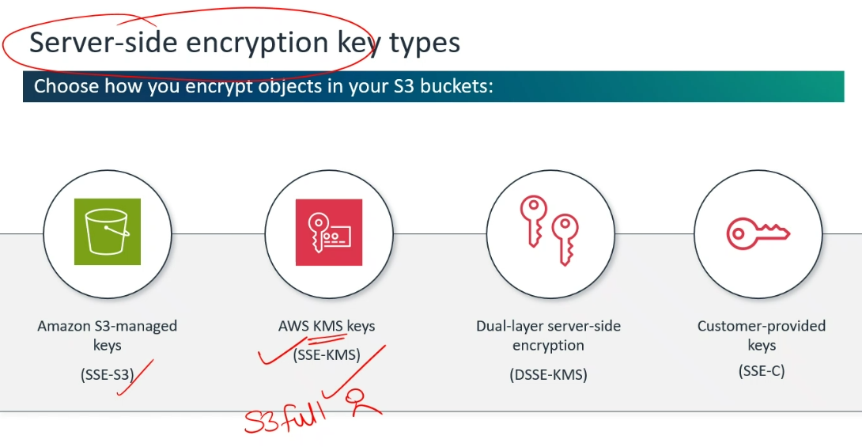

To prevent users from bypassing CloudFront and accessing direct S3 object URLs, AWS relies on Origin Access Control (OAC) combined with a restrictive S3 Bucket Policy.
🛡️ Restricting Direct Access with CloudFront OAC
  - ⚙️ Origin Access Control (OAC): Configures CloudFront to authenticate requests sent to the S3 origin using AWS IAM signature version 4 (SigV4).
  - 📜 S3 Bucket Policy Update: The S3 bucket policy is modified to grant s3:GetObject permission strictly to the CloudFront distribution service principal (cloudfront.amazonaws.com) matching your specific distribution ARN.
  - 🚫 Direct Access Prevention: Any user attempting to open a direct S3 URL ([https://bucket-name.s3.amazonaws.com/video.mp4](https://bucket-name.s3.amazonaws.com/video.mp4)) receives an HTTP 403 Forbidden error. All traffic must pass through CloudFront, where access controls and edge security logic are enforced.

🔒 What is Digital Rights Management (DRM)?
  - 📖 Definition: DRM is a framework of encryption and access control technologies designed to protect digital media (movies, TV shows, music) from unauthorized copying, downloading, and redistribution.

✅ Authorized Request Flow (Through CloudFront)
  - 🔀 Client Request: The user or app requests video content using the CloudFront URL (e.g., [https://d1111111abcdef.cloudfront.net/stream.m3u8](https://d1111111abcdef.cloudfront.net/stream.m3u8)).
  - 🛡️ Edge Security & DRM Check: CloudFront receives the request and validates edge authorization (e.g., CloudFront Signed URLs, Signed Cookies, or DRM license authentication).
  - ⚙️ OAC Signature Generation: CloudFront signs the fetch request to S3 using AWS Signature Version 4 (SigV4) on behalf of its service principal (cloudfront.amazonaws.com).
  - 🔐 S3 Bucket Policy Authorization: S3 receives the origin request, checks the bucket policy, and verifies that the request originates from the authorized CloudFront distribution ARN via OAC.
  - 📦 Content Delivery: S3 serves the encrypted video segment back to CloudFront, which caches and streams it securely to the user.

❌ Direct Access Attempt Flow (Bypassing CloudFront)
  - ⚠️ Direct Request: A user attempts to bypass CloudFront by navigating directly to the S3 URL (e.g., [https://my-bucket.s3.amazonaws.com/stream.m3u8](https://my-bucket.s3.amazonaws.com/stream.m3u8)).
  - 🔍 S3 Evaluation: S3 checks the bucket policy for direct public access.
  - 🛑 Access Denied: Because the request lacks the required CloudFront OAC SigV4 signature, S3 rejects the request immediately with an HTTP 403 Forbidden error, preventing unauthenticated access to the raw files.


*In Glacier, the data will be freeze and so it takes time for the retrieval of data.
*Object should be stored for 15 years - Go for "S3 Glacier Deep Archive".
*More time to retrieval, less cost it incurs…
*If you don't know , what storage class you need to select --> Go for "S3 Intelligent Tiering".
(Observation of "S3 Intelligent Tiering" -->Incurs the cost)
*Auto-deletion is not available. (Google it)
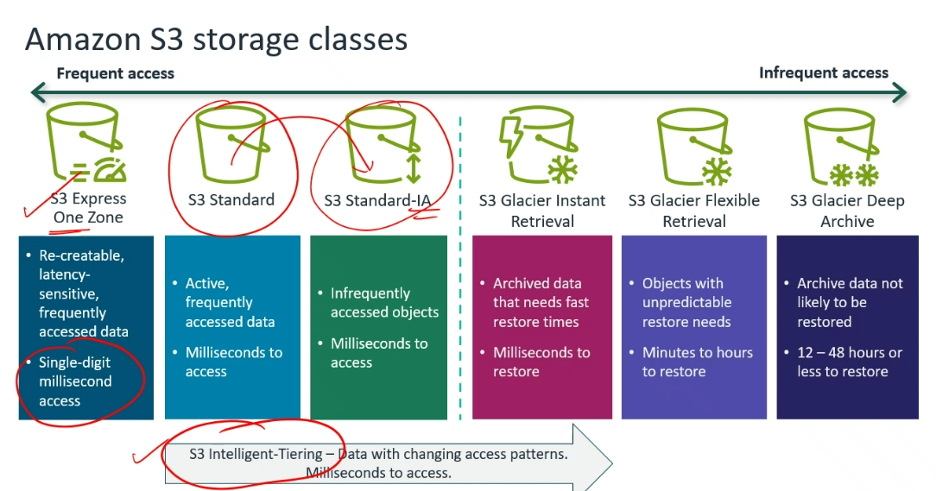

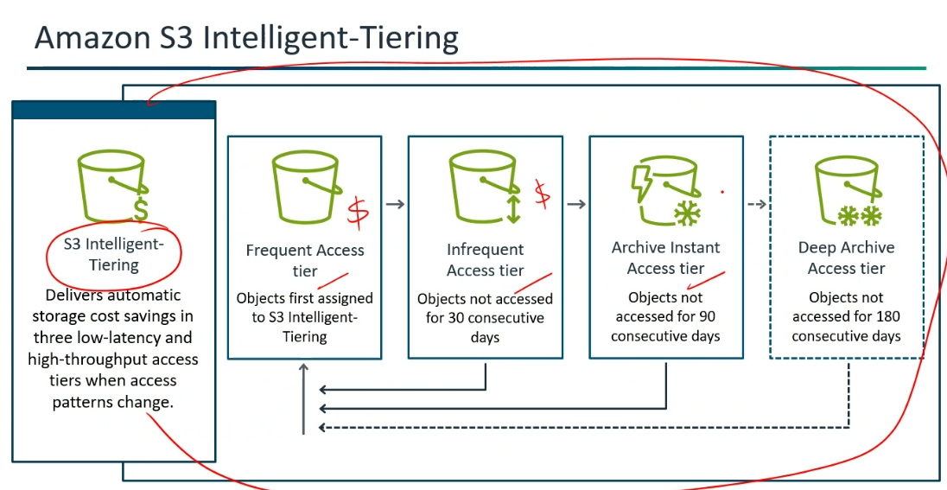

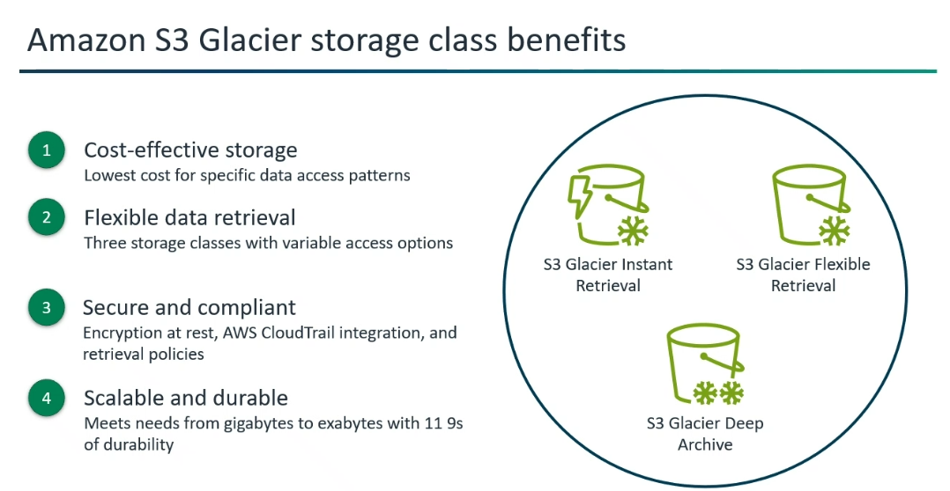
*"Versioning" saves accidental deletion of Objects.
*Lifecycle policies are the rules are defining the storage of that object.
*Even if versioning is enabled, after 500 days (need to delete) -->Delete Object.
*In S3 Intelligent Tiering --> Cost vary, but it will be in the S3 Intelligent Tiering class.
*Replication of S3 Object is possible --> But the storage price will get increased.
🪣 Amazon S3 — Advanced Concepts

Storage Classes · Storage Lens · Access Analyzer · Multipart Upload
Event Notifications · Cost Factors · Transfer Acceleration · Replication

🗂️ 1. S3 Storage Classes
🎯 What is it? Different storage tiers designed around how often you access data — choose the right class to balance performance and cost.

📊 All Storage Classes at a Glance
🗂️ Class | 🎯 Best For | ⏱️ Retrieval | 📅 Min Days | 💰 Cost
☀️ S3 Standard | Frequently accessed data  (websites, apps, gaming) | Milliseconds | None | Highest storage  No retrieval fee
🧠 Intelligent-Tiering | Unknown / unpredictable  access patterns | Milliseconds | None | Monitoring fee  + tiered rate
🌤️ Standard-IA | Infrequently accessed  (backups, DR files) | Milliseconds | 30 days | Low storage  Retrieval fee
🏠 One Zone-IA | Non-critical infrequent data  (secondary backups) | Milliseconds | 30 days | ~20% cheaper than  Standard-IA
🧊 Glacier Instant Retrieval | Archives needing  instant access | Milliseconds | 90 days | Very low storage  Retrieval fee
❄️ Glacier Flexible Retrieval | Archives accessed  1–2 times per year | Minutes–Hours | 90 days | Lower than  Instant Retrieval
🥶 Glacier Deep Archive | Long-term compliance  archives (< once/year) | 12–48 Hours | 180 days | Lowest cost  in all of S3
🚀 S3 Express One Zone | High-performance,  latency-sensitive (ML, HPC) | Single-digit ms | None | Higher than Standard  Optimised for speed

🧠 Intelligent-Tiering — How Auto-Tiering Works
ℹ️ Objects automatically move between tiers based on access. No manual intervention needed — AWS does it for you.

📂 Tier | ⏱️ When Object Moves Here | 💰 Cost Level
⚡ Frequent Access | Default — starts here on upload | Standard rate
🌤️ Infrequent Access | Not accessed for 30 days | Lower rate
🗄️ Archive Instant Access | Not accessed for 90 days | Very low rate
❄️ Archive Access | Not accessed for 90–730 days | Glacier rate
🥶 Deep Archive Access | Not accessed for 180–730 days | Deep Archive rate

💡 Exam Tip: Intelligent-Tiering = answer when the exam says "unpredictable" or "unknown" access patterns.
🔄 S3 Lifecycle Rules — Auto-Transition Objects
ℹ️ Lifecycle Rules automate moving objects between storage classes based on age — saving cost without any manual work.

  - ⚙️ Transition Actions → Move objects to a cheaper class after N days (e.g., Standard → Standard-IA at day 30 → Glacier at day 90)
  - 🗑️ Expiration Actions → Automatically delete objects or old versions after a set number of days
  - 🔀 Non-Current Versions → Rules can target previous versions of versioned objects separately from the latest version

💡 Exam Tip: Lifecycle Rules are the #1 cost-control tool for S3 at scale — always mention them when the exam asks about reducing S3 storage costs.

🔭 2. S3 Storage Lens
🎯 What is it? An organisation-wide analytics dashboard that gives you visibility into S3 usage, activity trends, and cost-optimisation recommendations — across ALL accounts and buckets in AWS Organizations.

📊 Key Capabilities
⚙️ Capability | 📋 What It Does
🌐 Organisation-Wide View | Aggregates metrics across ALL AWS accounts and buckets in an AWS Organization from a single dashboard
📈 Usage & Activity Metrics | Tracks total storage, object counts, request rates, data transfer volumes, and growth trends over time
💡 Cost Recommendations | Surfaces actionable suggestions — e.g., buckets with incomplete multipart uploads, excess non-current versions, or missing lifecycle rules
📤 Metrics Export | Exports daily metrics to S3 in CSV or Parquet format — can then be queried with Athena or visualised in QuickSight
🆓 Free vs Advanced Tier | Free: 28 usage metrics. Advanced (paid): 35+ additional metrics including request rates, data transfer, and prefix-level breakdown

💡 Exam Tip: Storage Lens = answer when exam asks "organisation-wide S3 visibility" or "cost optimisation recommendations across all accounts".

🔍 3. Access Analyzer for S3
🎯 What is it? Continuously scans bucket policies, ACLs, and access point policies to detect any bucket that is unintentionally public or shared with another AWS account — and raises a finding for review.

⚙️ How It Works
  - 🔍 Continuously evaluates all S3 bucket policies, ACLs, and access point policies automatically
  - 🌐 Flags any bucket reachable by anonymous (unauthenticated) users → Public Access finding
  - 🔀 Flags any bucket accessible from outside your AWS Organization → Cross-Account finding
  - 📋 Centralised Findings Dashboard — shows affected bucket, access level, and the principal that has access
  - ✅ Archive Findings — once reviewed and confirmed as intentional, archive the finding to suppress future alerts

⚖️ Access Analyzer for S3 vs IAM Access Analyzer
🔍 Tool | 🎯 Scope | 📋 What It Checks
🪣 Access Analyzer for S3 | S3 buckets only | Bucket policies, ACLs, access point policies  Detects public & cross-account bucket exposure
🧑 IAM Access Analyzer | All resource types | IAM roles, KMS keys, SQS, Lambda, Secrets Manager  Detects any unintended external access

💡 Exam Tip: S3 bucket public/cross-account exposure → Access Analyzer for S3. Broader IAM-level analysis → IAM Access Analyzer.

⬆️ 4. S3 Multipart Upload
🎯 What is it? Splits a large file into smaller parts, uploads them independently and in parallel, then S3 reassembles them — improving speed, reliability, and allowing resumable uploads for large files.

📐 Size Thresholds — When to Use It
📏 Threshold | 🔢 Value | 📋 Meaning
✅ Recommended From | ≥ 100 MB | AWS recommends using multipart upload for any file 100 MB or larger
🔴 Required From | > 5 GB | Single PUT upload limit — MUST use multipart for anything over 5 GB
📦 Max Object Size | 5 TB | Maximum size of a single S3 object
🔢 Max Parts | 10,000 | Maximum number of parts per multipart upload
📄 Min Part Size | 5 MB | Minimum size per part (except the very last part)
📄 Max Part Size | 5 GB | Maximum size per individual part

🔢 Step-by-Step Flow
Step | API Call | What Happens
1️⃣ Initiate | CreateMultipartUpload | S3 returns an Upload ID — use this ID for all subsequent part uploads
2️⃣ Upload Parts | UploadPart | Upload each part independently using the Upload ID — parts can be uploaded in parallel
3️⃣ Complete | CompleteMultipartUpload | Send the list of part ETags — S3 assembles all parts into the final object
4️⃣ Abort (opt.) | AbortMultipartUpload | Cancels the upload and deletes all uploaded parts to stop accruing storage charges

⚠️ Note: Incomplete multipart uploads still accrue storage charges for the uploaded parts — even if the final object is never completed. Always set a Lifecycle Rule with AbortIncompleteMultipartUpload to auto-clean stale parts after N days.

💡 Exam Tip: S3 Storage Lens surfaces buckets with high incomplete multipart upload accumulation — a common cost-saving finding.

🔔 5. S3 Event Notifications
🎯 What is it? Automatically triggers downstream AWS services when something happens in a bucket (e.g., file uploaded, deleted, restored) — enabling fully event-driven, serverless architectures without any polling.

⚡ Supported Event Types
📌 Event | 🔑 API / Action | 📋 When It Fires
📥 Object Created | s3:ObjectCreated:* | PUT, POST, COPY, or CompleteMultipartUpload — any new object lands in the bucket
🗑️ Object Removed | s3:ObjectRemoved:* | Object deleted — either a permanent delete or a Delete Marker is created
🔄 Object Restored | s3:ObjectRestore:* | A Glacier restore is initiated or completed
🔁 Replication | s3:Replication:* | Replication missed the threshold or replicated after the threshold

🎯 Destination Options
📤 Destination | 🎯 Best For | ⚙️ Key Point
⚡ AWS Lambda | Process, transform, or validate the uploaded file | Invoked directly — no queue needed
📨 Amazon SNS | Fan-out — notify multiple subscribers at once | Can trigger email, SMS, SQS, and Lambda simultaneously
📬 Amazon SQS | Buffer and queue high-volume S3 events reliably | Decouples S3 from downstream processing
🌉 Amazon EventBridge | Advanced routing with content-based filtering | Supports 18+ AWS targets and complex filter rules — more powerful than native S3 notifications

💡 Exam Tip: Multiple destinations OR complex filters → use Amazon EventBridge. Simple single-destination trigger → native S3 notification (SNS / SQS / Lambda).
🔐 Permission Requirement
ℹ️ The destination service must have a resource-based policy allowing S3 to invoke it. For EventBridge, just enable "Send notifications to EventBridge" on the bucket — no extra policy needed.

💰 6. S3 Cost Factors
🎯 What is it? S3 pricing has multiple dimensions — you pay for storage volume, API requests, data retrieval, data transfer out, and management features. Each dimension has optimisation levers.

💲 Cost Dimensions & How to Optimise Each
💲 Cost Dimension | 📋 What You Pay For | 💡 How to Reduce It
🗄️ Storage | Per GB per month — rate varies by storage class | Use Lifecycle Rules to move objects to cheaper classes; delete unneeded versions
📨 Requests | Per API call — PUT/COPY/POST/LIST cost more than GET | Use S3 Batch Operations instead of individual API calls; avoid unnecessary LIST operations
📤 Data Retrieval | IA and Glacier classes charge a per-GB retrieval fee | Match storage class to actual access frequency — avoid frequent retrieval from IA/Glacier classes
🌐 Data Transfer Out | Per GB transferred to the internet — data IN to S3 is free | Use CloudFront to cache and serve content — reduces repeated data egress charges from S3
⬆️ Incomplete Parts | Uploaded parts from unfinished multipart uploads accumulate silently | Set AbortIncompleteMultipartUpload Lifecycle Rule to auto-delete stale parts after N days
📦 Version Storage | Every object version is billed as a full separate copy — versions grow silently | Lifecycle Rule to expire non-current versions after N days
⚙️ Management Fees | Storage Lens Advanced tier, Intelligent-Tiering monitoring, CRR transfer charges | Evaluate whether the analytics/replication benefit justifies the added management cost

💡 Exam Tip: Most common exam cost answer: Lifecycle Rules + correct storage class + CloudFront caching = lowest total S3 spend.

🚀 7. S3 Transfer Acceleration
🎯 What is it? Speeds up long-distance uploads to S3 by routing data through the nearest CloudFront Edge Location, then transferring it to S3 via AWS's private backbone network — instead of the slow public internet.

⚙️ How It Works — Step by Step
Step | What Happens
1️⃣ Enable | Turn on Transfer Acceleration on the S3 bucket (one click in the console)
2️⃣ Upload | Client uploads to: <bucket>.s3-accelerate.amazonaws.com instead of the standard endpoint
3️⃣ Edge Location | Request is routed to the nearest CloudFront Edge Location geographically closest to the client
4️⃣ Backbone | Data travels from the Edge Location to the S3 bucket over AWS's private, optimised backbone network

📋 Key Facts
✅ Best For: Clients uploading large files from locations geographically far from the S3 bucket region
🌐 Endpoint: <bucket-name>.s3-accelerate.amazonaws.com
💰 Cost: Additional per-GB charge on top of standard S3 transfer — only pay when Transfer Acceleration is faster than a standard upload
🔴 Not Beneficial: Clients that are already close to the S3 bucket region — no speed improvement
🔀 Works Best With: Multipart Upload — combining both gives maximum throughput for large, long-distance uploads

⚖️ Transfer Acceleration vs CloudFront vs Global Accelerator
⚙️ Service | 🎯 Optimises | 📋 Use When
🚀 S3 Transfer Acceleration | S3 UPLOADS from distant global clients | Uploading large files to S3 from worldwide users
🌐 CloudFront | Content DOWNLOADS and reads (cached) | Serving static content globally with low latency
⚡ Global Accelerator | TCP/UDP application traffic routing | Speeding up non-HTTP workloads or multi-region app routing

💡 Exam Tip: Transfer Acceleration = UPLOADS to S3. CloudFront = DOWNLOADS from S3. They are complementary, not alternatives.

🔀 8. S3 Replication
🎯 What is it? Automatically and asynchronously copies objects from a source bucket to a destination bucket — either within the same region (SRR) or across different regions (CRR).

⚖️ SRR vs CRR — Side by Side
📋 Property | 🔵 Same-Region Replication (SRR) | 🌍 Cross-Region Replication (CRR)
🌐 Regions | Source and destination in the SAME AWS region | Source and destination in DIFFERENT AWS regions
🎯 Use Cases | Log aggregation across accounts  Live replication between prod & test  Compliance within same region | Disaster recovery in another region  Lower latency for global users  Geo-separated compliance requirement
💰 Data Transfer | No inter-region transfer charges | Standard inter-region data transfer charges apply
⚙️ Prerequisite | Versioning MUST be enabled on BOTH buckets | Versioning MUST be enabled on BOTH buckets

📋 Important Replication Rules to Know
📌 Rule | 📋 Detail
✅ Versioning Required | Must be enabled on BOTH source and destination buckets — without it, replication cannot be configured
⏩ Asynchronous | Replication happens in the background — not real-time, but typically completes within seconds to minutes
🔐 IAM Role Required | S3 needs an IAM role with read permissions on the source and write permissions on the destination
🌐 Cross-Account Support | CRR can replicate to a bucket in a different AWS account — the destination bucket policy must grant the source account write access
🔁 No Retroactive Copy | Only NEW objects uploaded after the rule is created are replicated — existing objects are NOT automatically copied
🗑️ Delete Marker Replication | Disabled by default — must explicitly enable it in the replication rule if you want deletions to propagate to the destination
🔗 No Chaining | Bucket A → Bucket B → Bucket C does NOT work automatically. Objects in A do not replicate all the way to C

🔄 S3 Batch Replication
ℹ️ Use Batch Replication to replicate existing objects that were present before a replication rule was set up, or objects that previously failed to replicate. It is a one-time on-demand job — not a continuous background rule.

⏱️ S3 Replication Time Control (RTC)
🎯 Purpose: Provides an SLA-backed guarantee that 99.99% of new objects are replicated within 15 minutes
📊 Monitoring: Includes replication lag metrics and CloudWatch alarms
💰 Cost: Additional charge on top of standard replication costs

💡 Exam Tip: RTC = answer when the exam asks for a guaranteed replication time SLA for compliance or disaster recovery requirements.

🎯 Exam Scenario Quick Reference — All 8 Topics

📋 Exam Says... | ✅ Answer
Unknown or unpredictable S3 access patterns | S3 Intelligent-Tiering
Cheapest long-term archive, 12–48 hour retrieval is acceptable | S3 Glacier Deep Archive
Archive data but must retrieve in milliseconds | S3 Glacier Instant Retrieval
Organisation-wide S3 usage visibility and cost recommendations | S3 Storage Lens
Detect buckets with unintended public or cross-account access | Access Analyzer for S3
File is larger than 5 GB — how do you upload it? | Multipart Upload (mandatory above 5 GB)
Trigger Lambda automatically when a file is uploaded to S3 | S3 Event Notification → Lambda
Route S3 events to multiple destinations with complex filters | Amazon EventBridge
Speed up uploads to S3 from users around the world | S3 Transfer Acceleration
Incomplete multipart uploads are costing too much | Lifecycle Rule: AbortIncompleteMultipartUpload
Reduce repeated S3 data transfer costs for read-heavy workloads | Amazon CloudFront (cache at edge)
Transition objects automatically to cheaper storage over time | S3 Lifecycle Rules
Replicate data to another region for disaster recovery | Cross-Region Replication (CRR)
Replicate existing objects created before replication was configured | S3 Batch Replication
Guarantee objects replicate within 15 minutes (compliance SLA) | S3 Replication Time Control (RTC)
Replication rule is set but objects are not replicating — why? | Check: Versioning must be enabled on BOTH buckets

🪣 Amazon S3 Advanced Concepts | All Content Preserved | AWS SAA-C03 Exam Prep 🪣

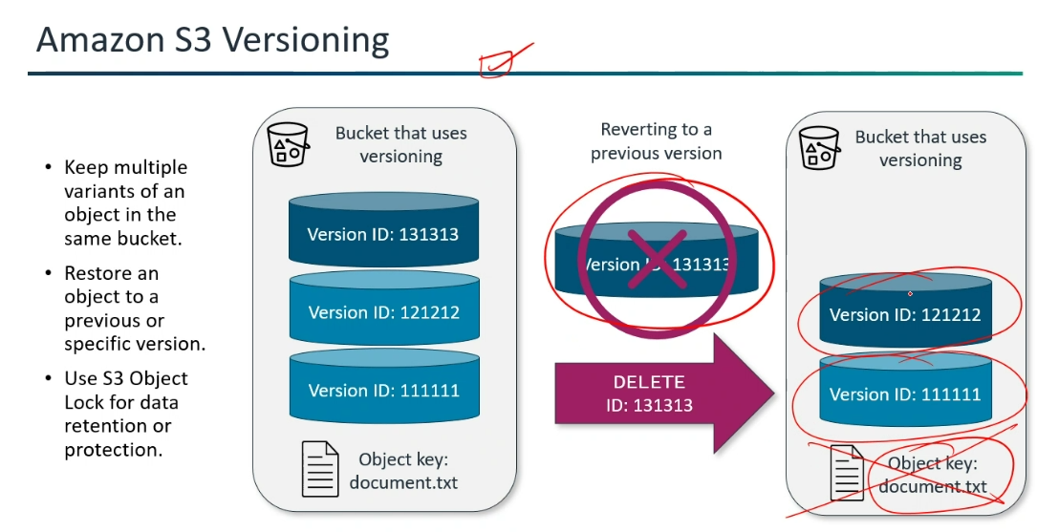

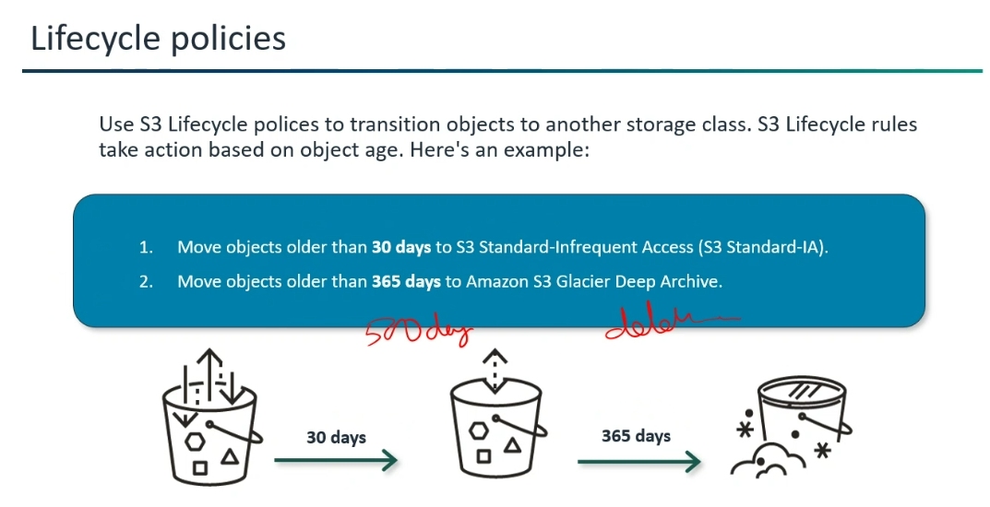

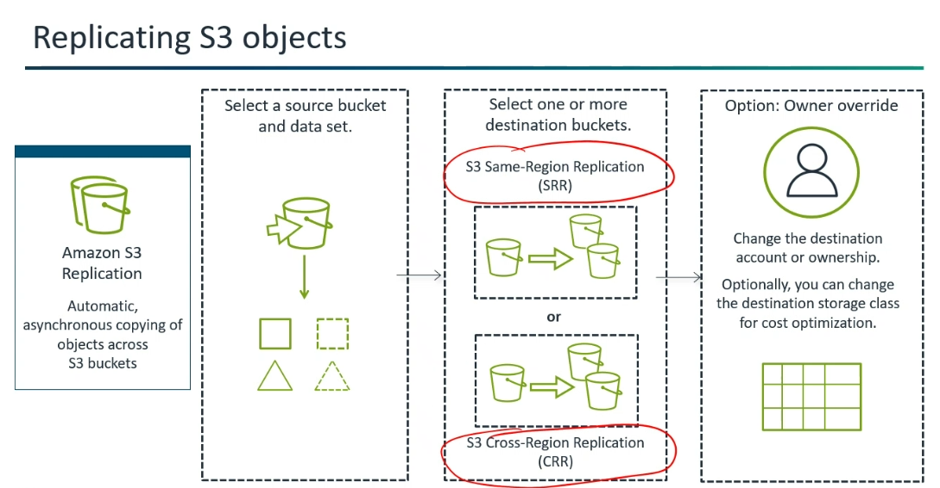


*In uploading, if network fails accidently, then when again network is back -->
it will resume from where it left.
*If each objects get uploaded to 100% then only the user can able to access (Free of Cost)
(Not able to access in console only in CLI).
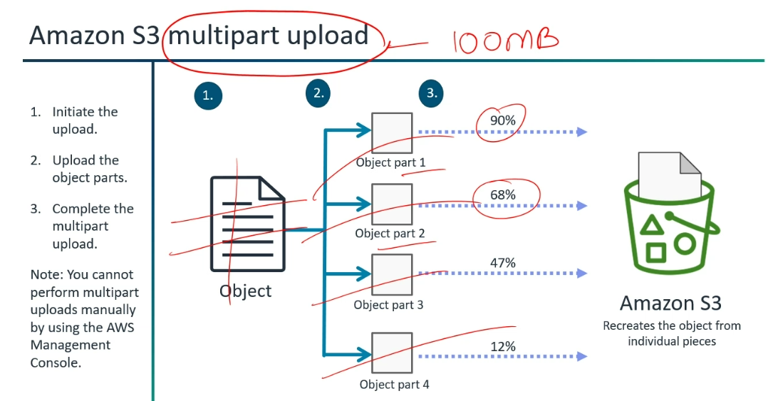
*To complete the round trip path, we need to rely on the internet.
*To overcome it, we rely on Amazon Network --> Amazon S3 Transfer Acceleration.
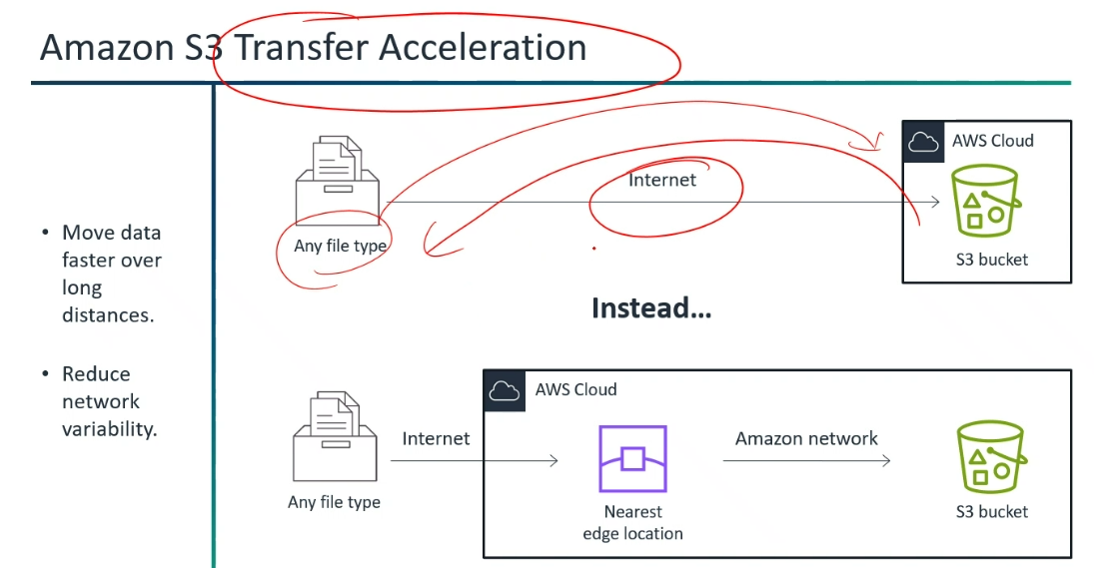
*Event notification is a resource for S3.
* Lambda is a target.
*Across the region -->Data transfer --> Cost will be charged.
*Performing of replication not incurs the cost but the "Data" incurs..(Takes space will incurs the cost)
*Region wise cost will be different.
*Leverage the multi-part feature --> Single object uploaded limit is 5TB.
But we can upload "N" no. of objects.
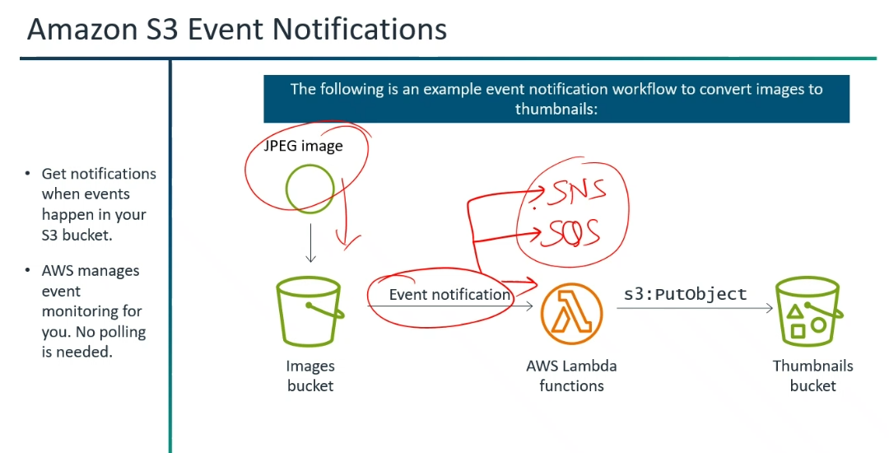

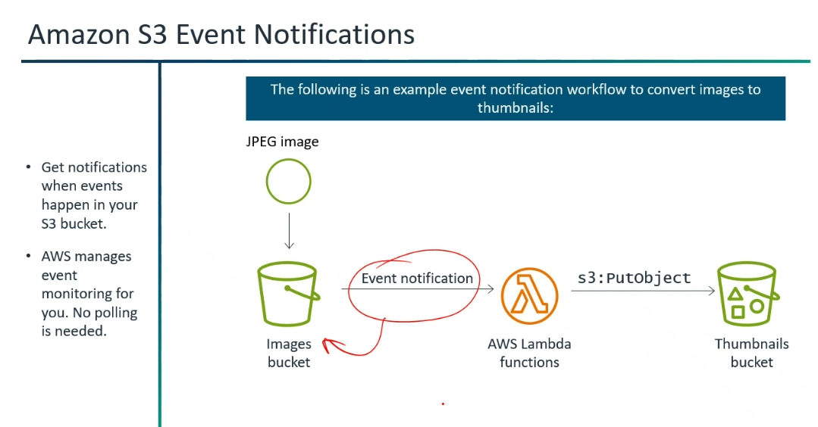

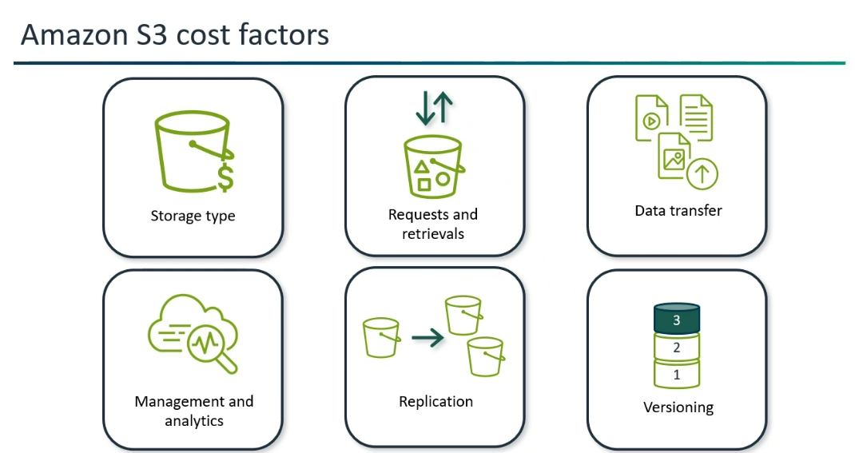

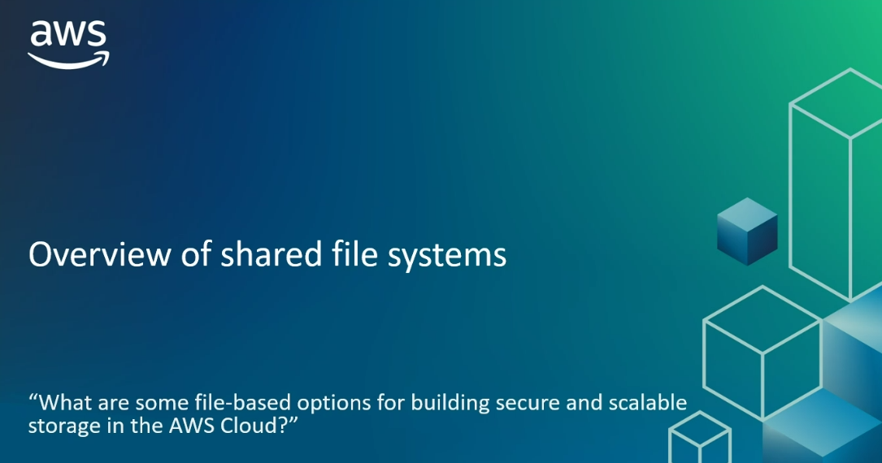

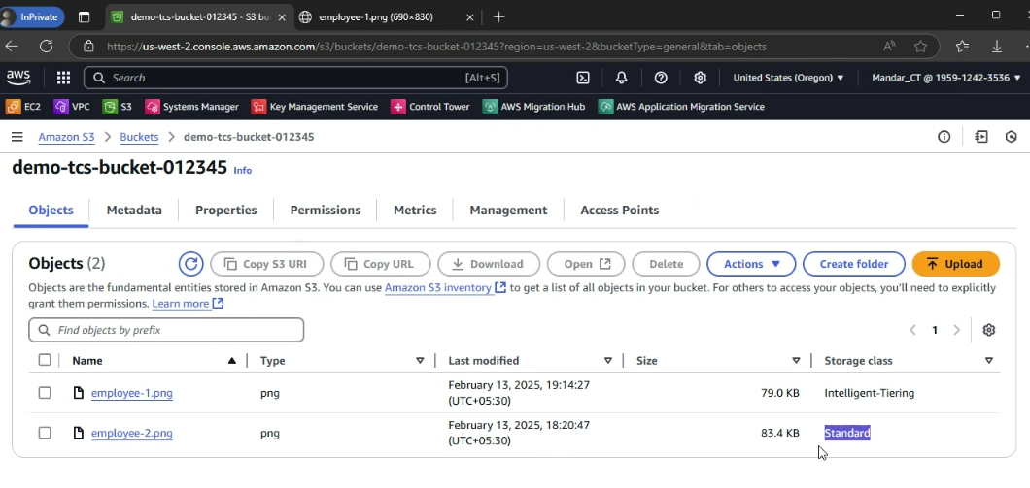

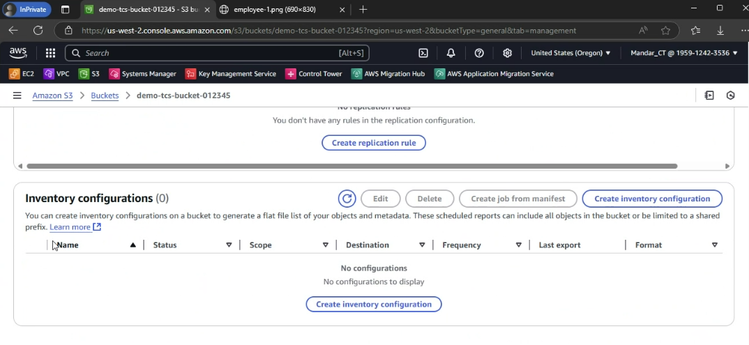

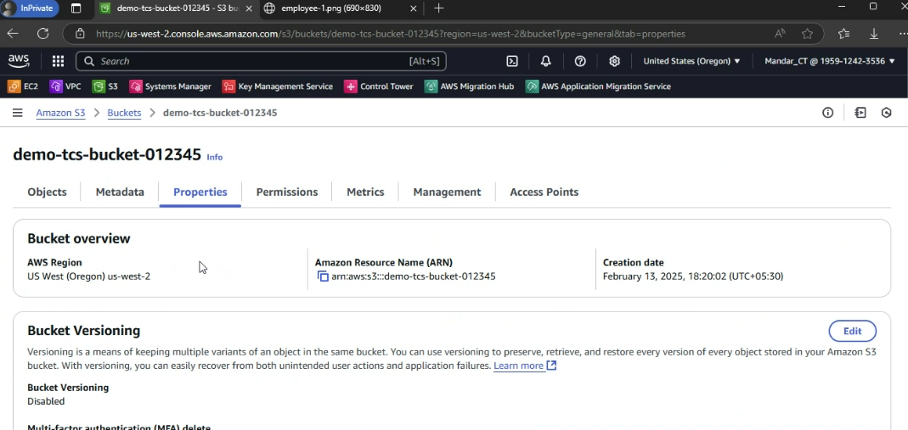

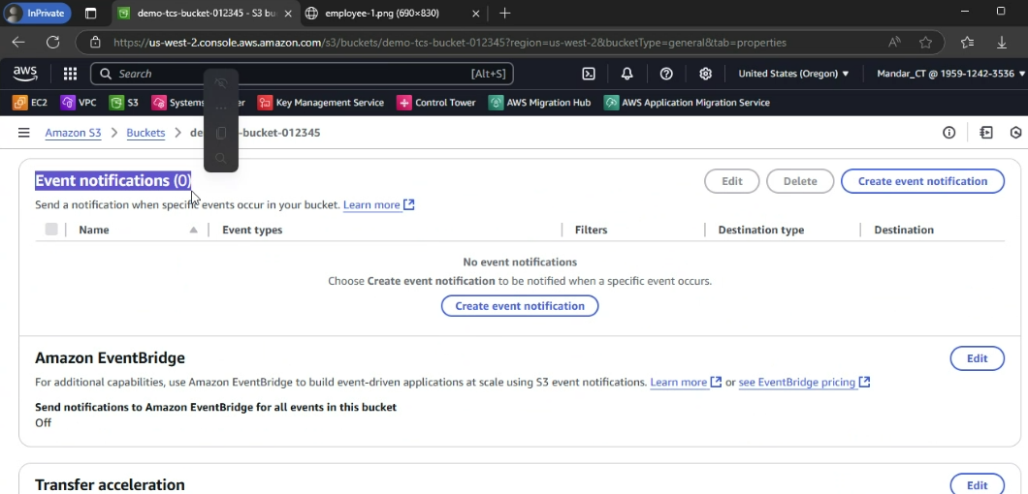

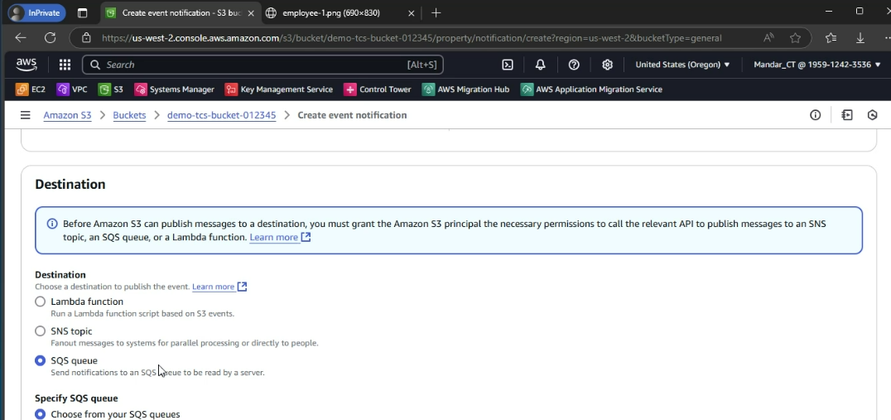
S3 Storage Lens
*It is a powerful tool, it provides "Object Storage Usage and Activity Trends within S3".
*Options:
Overview
Accounts
AWS Regions
Storage classes (In Storage Class, it gives "No storage class -->-; Standard--->348.0 GB; Standard-IA-->77.3 GB")
Buckets
Prefixes
Storage Lens groups
*We can use "Metrics" to filter out the particular data.
For instance: Active Buckets, Object Count.
*"Bubble analysis" in AWS S3graphical representation with three dimensions: x-axis, y-axis, and bubble size, representing metrics like total storage, retrieval rate, and average object size.
This allows for identifying cold buckets (low retrieval rate, high storage) and optimizing storage costs.
*Storage Lens is a free tier.
It has advanced metrics and recommendations available for an additional monthly per-object monitoring charge.
Access Analyzer for S3
AWS IAM Access Analyzer helps you identify the resources in your AWS account that are shared with an external entity. This is crucial for security because it helps you understand who has access to your data and resources outside of your AWS account.

Access Analyzer for S3 is a feature that helps you identify and review buckets with access paths that are accessible from outside your AWS account. This helps you to proactively address potential security risks by understanding who has access to your data.

